Team #1

Team Members:

What are the effects of Sini-cide e-liquid and aerosol on cilia beat frequency?

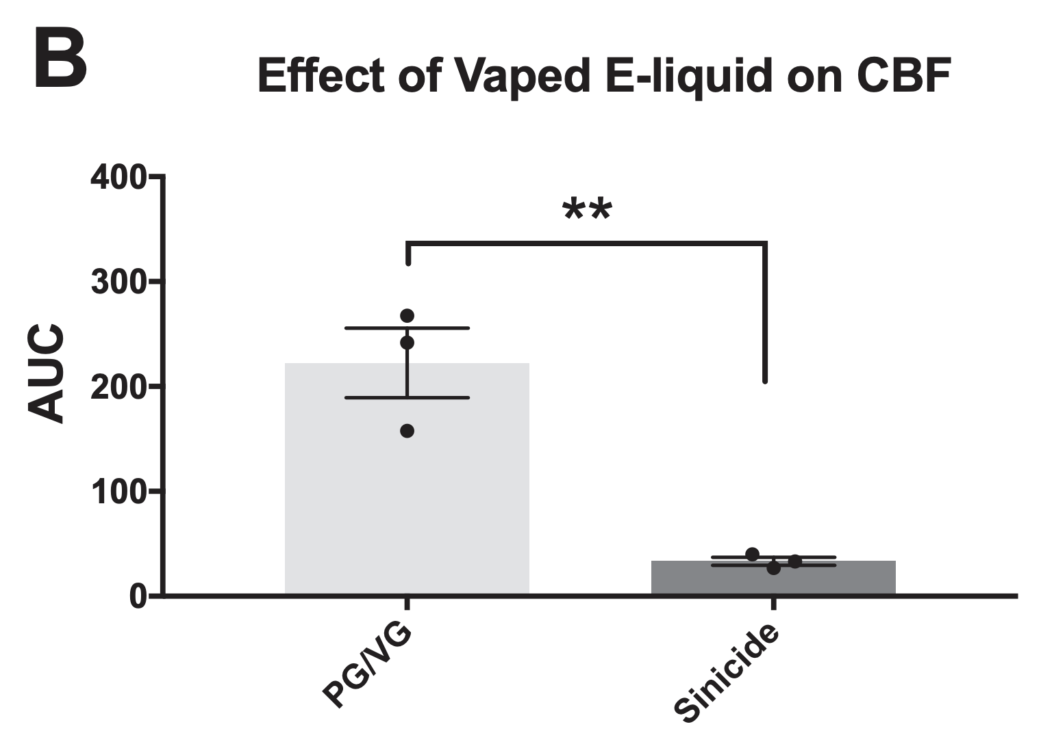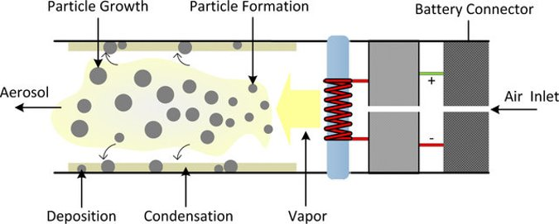
Aerosol
E-Liquid
Total Ciliary Beat Frequency (CBF)

Observation / Conclusions:

Team #2

Team Members:

How does the concentration of cinnamaldehyde impact cilia beat frequency?

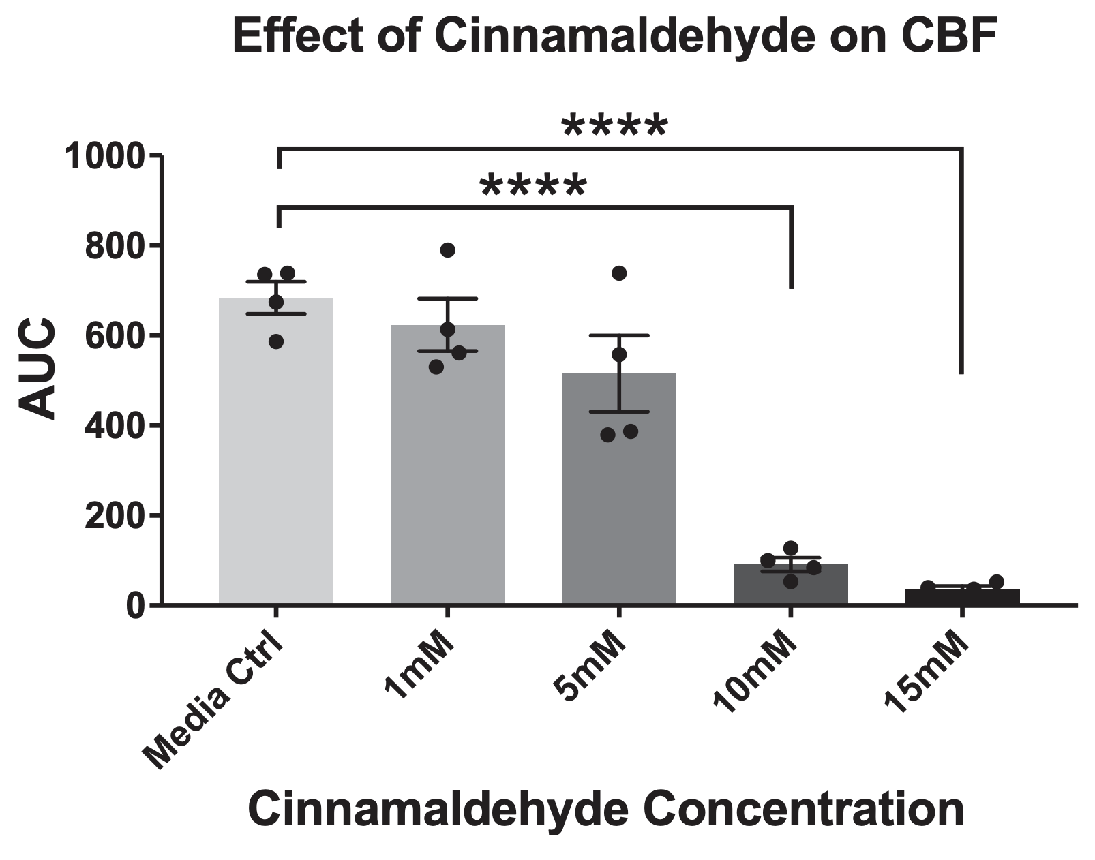
Total Ciliary Beat Frequency (CBF)

Observation / Conclusions:

Team #3

Team Members:

How does the concentration of cinnamaldehyde impact mitochondrial function?

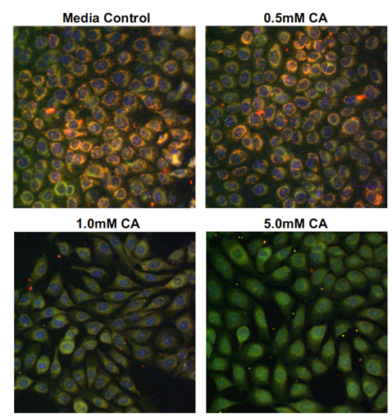
Human lung epithelial cells were exposed to different concentrations of cinnamaldehyde (CA) and then mitochondrial function was measured.

Red = High functioning mitochondria
Green = Low functioning mitochondria

Observation / Conclusions:

Team #4

Team Members:

How does the concentration of cinnamaldehyde impact ATP production?

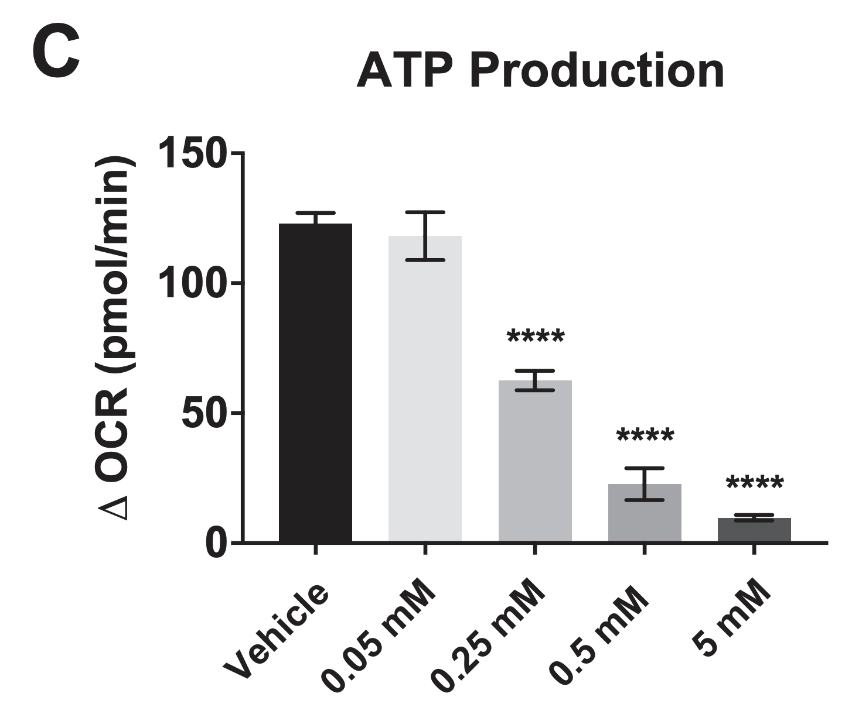
ATP Concentration
0.25
0.5
5.0
Cinnamaldehyde Concentration (mM)
0
0.05

Observation / Conclusions:

